Additional file 1: Table S1. GO enrichment analysis for the putative high mutation genes

GO term | Ontology | Description | Number in input list | Number in BG/Ref | p-value | FDR | -log₁₀ FDR
GO:0006200 | P | ATP catabolic process | 36 | 267 | 1.90E-06 | 0.0011 | 2.958607315
GO:0009261 | P | ribonucleotide catabolic process | 43 | 373 | 1.30E-05 | 0.0072 | 2.142667504
GO:0006195 | P | purine nucleotide catabolic process | 43 | 373 | 1.30E-05 | 0.0072 | 2.142667504
GO:0009146 | P | purine nucleoside triphosphate catabolic process | 43 | 373 | 1.30E-05 | 0.0072 | 2.142667504
GO:0009203 | P | ribonucleoside triphosphate catabolic process | 43 | 373 | 1.30E-05 | 0.0072 | 2.142667504
GO:0009207 | P | purine ribonucleoside triphosphate catabolic process | 43 | 373 | 1.30E-05 | 0.0072 | 2.142667504
GO:0009154 | P | purine ribonucleotide catabolic process | 43 | 373 | 1.30E-05 | 0.0072 | 2.142667504
GO:0009143 | P | nucleoside triphosphate catabolic process | 43 | 374 | 1.40E-05 | 0.0077 | 2.113509275
GO:0009150 | P | purine ribonucleotide metabolic process | 47 | 423 | 1.40E-05 | 0.0079 | 2.102372909
GO:0009166 | P | nucleotide catabolic process | 43 | 375 | 1.40E-05 | 0.0082 | 2.086186148
GO:0006163 | P | purine nucleotide metabolic process | 48 | 436 | 1.50E-05 | 0.0082 | 2.086186148
GO:0046034 | P | ATP metabolic process | 36 | 294 | 1.60E-05 | 0.0093 | 2.031517051
GO:0009144 | P | purine nucleoside triphosphate metabolic process | 44 | 404 | 4.00E-05 | 0.023 | 1.638272164
GO:0009205 | P | purine ribonucleoside triphosphate metabolic process | 44 | 404 | 4.00E-05 | 0.023 | 1.638272164
GO:0009199 | P | ribonucleoside triphosphate metabolic process | 44 | 411 | 6.00E-05 | 0.034 | 1.468521083
GO:0009141 | P | nucleoside triphosphate metabolic process | 44 | 413 | 6.70E-05 | 0.038 | 1.420216403
GO:0017111 | F | nucleoside-triphosphatase activity | 67 | 618 | 7.40E-07 | 0.00011 | 3.958607315
GO:0016818 | F | hydrolase activity, acting on acid anhydrides, in phosphorus-containing anhydrides | 69 | 649 | 1.00E-06 | 0.00016 | 3.795880017
Table S1. (Continued)
GO term | Ontology | Description | Number in input list | Number in BG/Ref | p-value | FDR | -log₁₀ FDR
GO:0016887 | F | ATPase activity | 44 | 350 | 1.10E-06 | 0.00017 | 3.769551079
GO:0016462 | F | pyrophosphatase activity | 68 | 639 | 1.20E-06 | 0.00018 | 3.744727495
GO:0016817 | F | hydrolase activity, acting on acid anhydrides | 69 | 659 | 1.80E-06 | 0.00027 | 3.568636236
GO:0000166 | F | nucleotide binding | 189 | 2449 | 6.70E-05 | 0.01 | 2
GO:0005524 | F | ATP binding | 131 | 1615 | 8.50E-05 | 0.013 | 1.886056648
GO:0032559 | F | adenyl ribonucleotide binding | 132 | 1632 | 9.10E-05 | 0.014 | 1.853871964
GO:0030554 | F | adenyl nucleotide binding | 141 | 1763 | 9.30E-05 | 0.014 | 1.853871964
GO:0001883 | F | purine nucleoside binding | 141 | 1764 | 9.50E-05 | 0.014 | 1.853871964
GO:0001882 | F | nucleoside binding | 141 | 1774 | 0.00012 | 0.018 | 1.744727495
GO:0032555 | F | purine ribonucleotide binding | 144 | 1821 | 0.00013 | 0.02 | 1.698970004
GO:0032553 | F | ribonucleotide binding | 144 | 1821 | 0.00013 | 0.02 | 1.698970004
GO:0017076 | F | purine nucleotide binding | 153 | 1953 | 0.00013 | 0.02 | 1.698970004
GO:0042623 | F | ATPase activity, coupled | 31 | 274 | 0.00024 | 0.037 | 1.431798276

Additional file 2: Table S2. The genome positions of specific chloroplast DNA integration sites in SunUp

Type | Border Number | Scaffold | Insert Position |  |  | Position in orgDNA |  | E-value | Identity | Chromosome
 |  |  | Start | End |  | Start | End
reliable | one border found | supercontig_0 | 2534921 | 2535002 |  | 65309 | 65391 | 2.00E-26 | 95.18 | 6
 | one border found | supercontig_0 | 4570284 | 4571406 |  | 61413 | 62538 | 0 | 95.47 | 6
 | one border found | supercontig_1 | 4849106 | 4849367 |  | 79343 | 79082 | 1.00E-135 | 98.47 | 2
 | one border found | supercontig_2 | 1165138 | 1167532 |  | 149369 | 146974 | 0 | 94.5 | 2
 | one border found | supercontig_2 | 1165138 | 1167532 |  | 99481 | 101876 | 0 | 94.5 | 2
 | one border found | supercontig_2 | 1167600 | 1168987 |  | 102459 | 103848 | 0 | 94.25 | 2
 | one border found | supercontig_2 | 1167600 | 1168987 |  | 146391 | 145002 | 0 | 94.25 | 2
 | one border found | supercontig_2 | 1986365 | 1987213 |  | 56896 | 57744 | 0 | 99.76 | 2
 | both borders found | supercontig_4 | 2283181 | 2283317 |  | 131410 | 131545 | 3.00E-61 | 97.81 | 9
 | one border found | supercontig_5 | 1539355 | 1539605 |  | 104119 | 104369 | 5.00E-127 | 98.01 | 8
 | one border found | supercontig_5 | 1539355 | 1539605 |  | 144731 | 144481 | 5.00E-127 | 98.01 | 8
 | one border found | supercontig_6 | 1946612 | 1946853 |  | 62078 | 62320 | 5.00E-53 | 86.42 | 4
 | one border found | supercontig_6 | 2218545 | 2218805 |  | 37107 | 36847 | 9.00E-55 | 86.26 | 4
 | one border found | supercontig_7 | 2320984 | 2321189 |  | 18866 | 18661 | 3.00E-100 | 97.57 | 7
 | one border found | supercontig_9 | 2158403 | 2158546 |  | 154119 | 153977 | 3.00E-51 | 93.75 | 5
 | one border found | supercontig_9 | 2158403 | 2158546 |  | 94731 | 94873 | 3.00E-51 | 93.75 | 5
 | one border found | supercontig_11 | 934867 | 934979 |  | 150238 | 150126 | 3.00E-42 | 94.69 | 8
 | one border found | supercontig_11 | 934867 | 934979 |  | 98612 | 98724 | 3.00E-42 | 94.69 | 8
 | one border found | supercontig_11 | 2427206 | 2428804 |  | 59819 | 58220 | 0 | 94.07 | 8
 | both borders found | supercontig_12 | 64846 | 64996 |  | 114723 | 114573 | 5.00E-65 | 96.03 | 4
 | both borders found | supercontig_12 | 64846 | 64996 |  | 134127 | 134277 | 5.00E-65 | 96.03 | 4
 | one border found | supercontig_13 | 469538 | 471349 |  | 124373 | 126178 | 0 | 94.12 | 9
 | one border found | supercontig_15 | 866366 | 866657 |  | 155545 | 155837 | 8.00E-61 | 89.46 | 4
 | one border found | supercontig_15 | 866366 | 866657 |  | 93305 | 93013 | 8.00E-61 | 89.46 | 4
Table S2. (Continued)
Type | Border Number | Scaffold | Insert Position |  |  | Position in orgDNA |  | E-value | Identity | Chromosome
 |  |  | Start | End |  | Start | End
 | one border found | supercontig_16 | 2136292 | 2136559 |  | 112529 | 112799 | 1.00E-71 | 90.41 | 3
 | one border found | supercontig_16 | 2136292 | 2136559 |  | 136321 | 136051 | 1.00E-71 | 90.41 | 3
 | one border found | supercontig_17 | 2509534 | 2509642 |  | 102312 | 102420 | 2.00E-30 | 90.83 | 9
 | one border found | supercontig_17 | 2509534 | 2509642 |  | 146538 | 146430 | 2.00E-30 | 90.83 | 9
 | one border found | supercontig_18 | 386609 | 386788 |  | 111824 | 111645 | 9.00E-73 | 94.44 | 5
 | one border found | supercontig_18 | 386609 | 386788 |  | 137026 | 137205 | 9.00E-73 | 94.44 | 5
 | one border found | supercontig_22 | 1930257 | 1930370 |  | 131405 | 131292 | 2.00E-57 | 100 | 5
 | one border found | supercontig_23 | 2635636 | 2635721 |  | 152003 | 152088 | 1.00E-28 | 94.19 | 7
 | one border found | supercontig_23 | 2635636 | 2635721 |  | 96847 | 96762 | 1.00E-28 | 94.19 | 7
 | both borders found | supercontig_25 | 1423654 | 1423756 |  | 67142 | 67245 | 3.00E-44 | 98.08 | 4
 | both borders found | supercontig_26 | 1574754 | 1575148 |  | 153040 | 152647 | 0 | 98.99 | X/Y
 | both borders found | supercontig_26 | 1574754 | 1575148 |  | 95810 | 96203 | 0 | 98.99 | X/Y
 | one border found | supercontig_30 | 500302 | 500418 |  | 129493 | 129377 | 5.00E-40 | 93.16 | 2
 | one border found | supercontig_30 | 879921 | 880111 |  | 69886 | 70077 | 5.00E-52 | 92.19 | 2
 | one border found | supercontig_30 | 1101919 | 1102257 |  | 155991 | 155641 | 9.00E-131 | 95.73 | 2
 | one border found | supercontig_30 | 1101919 | 1102257 |  | 92859 | 93209 | 9.00E-131 | 95.73 | 2
 | one border found | supercontig_31 | 939865 | 940051 |  | 53789 | 53976 | 6.00E-49 | 88.83 | ND
 | one border found | supercontig_31 | 1279176 | 1279414 |  | 30010 | 29765 | 3.00E-66 | 94.72 | ND
 | both borders found | supercontig_33 | 1000440 | 1000759 |  | 61300 | 61618 | 4.00E-173 | 99.38 | 8
 | one border found | supercontig_33 | 1713169 | 1713496 |  | 82579 | 82911 | 1.00E-151 | 95.8 | 8
 | one border found | supercontig_35 | 695261 | 695444 |  | 3901 | 4087 | 2.00E-39 | 87.17 | 9
 | one border found | supercontig_37 | 47515 | 47758 |  | 109742 | 109987 | 9.00E-41 | 85.37 | 6
 | one border found | supercontig_37 | 47515 | 47758 |  | 139108 | 138863 | 9.00E-41 | 85.37 | 6
 | one border found | supercontig_37 | 97733 | 97923 |  | 151226 | 151410 | 7.00E-57 | 95.29 | 6
 | one border found | supercontig_37 | 97733 | 97923 |  | 97624 | 97440 | 7.00E-57 | 95.29 | 6
Table S2. (Continued)
Type | Border Number | Scaffold | Insert Position |  |  | Position in orgDNA |  | E-value | Identity | Chromosome
 |  |  | Start | End |  | Start | End
 | one border found | supercontig_37 | 97931 | 98131 |  | 110316 | 110114 | 4.00E-80 | 95.59 | 6
 | one border found | supercontig_37 | 97931 | 98131 |  | 138534 | 138736 | 4.00E-80 | 95.59 | 6
 | one border found | supercontig_38 | 1655889 | 1655996 |  | 11965 | 11858 | 8.00E-54 | 100 | 2
 | one border found | supercontig_40 | 859698 | 859801 |  | 104443 | 104546 | 2.00E-32 | 92.31 | 7
 | one border found | supercontig_40 | 859698 | 859801 |  | 144407 | 144304 | 2.00E-32 | 92.31 | 7
 | one border found | supercontig_40 | 859953 | 860053 |  | 104847 | 104946 | 2.00E-42 | 98.02 | 7
 | one border found | supercontig_40 | 859953 | 860053 |  | 144003 | 143904 | 2.00E-42 | 98.02 | 7
 | one border found | supercontig_41 | 1650414 | 1650610 |  | 110777 | 110974 | 4.00E-74 | 93.43 | 5
 | one border found | supercontig_41 | 1650414 | 1650610 |  | 138073 | 137876 | 4.00E-74 | 93.43 | 5
 | both borders found | supercontig_47 | 1192164 | 1192466 |  | 59440 | 59138 | 7.00E-125 | 93.73 | 2
 | one border found | supercontig_49 | 1401580 | 1401782 |  | 34180 | 34382 | 7.00E-63 | 93.63 | X/Y
 | one border found | supercontig_55 | 475537 | 476022 |  | 152281 | 151796 | 3.00E-83 | 84.57 | 4
 | one border found | supercontig_55 | 475537 | 476022 |  | 96569 | 97054 | 3.00E-83 | 84.57 | 4
 | one border found | supercontig_56 | 833131 | 833616 |  | 41241 | 41725 | 5.00E-79 | 82.92 | 8
 | one border found | supercontig_60 | 1471675 | 1471909 |  | 132350 | 132113 | 4.00E-58 | 87.82 | 6
 | one border found | supercontig_63 | 645779 | 646077 |  | 153508 | 153207 | 3.00E-120 | 97.69 | ND
 | one border found | supercontig_63 | 645779 | 646077 |  | 95342 | 95643 | 3.00E-120 | 97.69 | ND
 | one border found | supercontig_63 | 1194839 | 1194940 |  | 57276 | 57378 | 2.00E-41 | 97.09 | ND
 | one border found | supercontig_65 | 1401473 | 1402134 |  | 18326 | 17664 | 0 | 99.4 | ND
 | both borders found | supercontig_78 | 215493 | 216019 |  | 2634 | 3159 | 0 | 98.29 | 7
 | one border found | supercontig_88 | 196244 | 196308 |  | 127147 | 127211 | 1.00E-23 | 96.92 | ND
 | one border found | supercontig_103 | 763050 | 763355 |  | 101332 | 101019 | 1.00E-69 | 86.03 | 5
 | one border found | supercontig_103 | 763050 | 763355 |  | 147518 | 147831 | 1.00E-69 | 86.03 | 5
 | one border found | supercontig_106 | 484861 | 484991 |  | 152416 | 152546 | 7.00E-68 | 100 | 6
 | one border found | supercontig_106 | 484861 | 484991 |  | 96434 | 96304 | 7.00E-68 | 100 | 6
Table S2. (Continued)
Type | Border Number | Scaffold | Insert Position |  |  | Position in orgDNA |  | E-value | Identity | Chromosome
 |  |  | Start | End |  | Start | End
 | both borders found | supercontig_107 | 157083 | 157227 |  | 32784 | 32930 | 1.00E-53 | 94.56 | 9
 | one border found | supercontig_109 | 310260 | 310462 |  | 11317 | 11520 | 3.00E-61 | 90.2 | ND
 | both borders found | supercontig_113 | 505664 | 505739 |  | 38113 | 38037 | 3.00E-26 | 96.1 | 2
 | one border found | supercontig_119 | 154288 | 154354 |  | 152373 | 152307 | 5.00E-25 | 97.01 | 6
 | one border found | supercontig_119 | 154288 | 154354 |  | 96477 | 96543 | 5.00E-25 | 97.01 | 6
 | one border found | supercontig_125 | 882141 | 882344 |  | 109831 | 110036 | 1.00E-81 | 94.66 | 8
 | one border found | supercontig_125 | 882141 | 882344 |  | 139019 | 138814 | 1.00E-81 | 94.66 | 8
 | one border found | supercontig_131 | 667720 | 667990 |  | 12141 | 12409 | 2.00E-49 | 84.5 | 4
 | one border found | supercontig_134 | 968918 | 969061 |  | 155080 | 154936 | 2.00E-62 | 97.95 | 9
 | one border found | supercontig_134 | 968918 | 969061 |  | 93770 | 93914 | 2.00E-62 | 97.95 | 9
 | one border found | supercontig_141 | 719179 | 719423 |  | 7595 | 7351 | 1.00E-47 | 84.9 | 5
 | one border found | supercontig_143 | 231435 | 231646 |  | 110732 | 110946 | 9.00E-49 | 87.91 | ND
 | one border found | supercontig_143 | 231435 | 231646 |  | 138118 | 137904 | 9.00E-49 | 87.91 | ND
 | both borders found | supercontig_155 | 491419 | 491597 |  | 158759 | 158938 | 4.00E-69 | 95.03 | ND
 | both borders found | supercontig_155 | 491419 | 491597 |  | 90091 | 89912 | 4.00E-69 | 95.03 | ND
 | one border found | supercontig_185 | 355506 | 355627 |  | 73414 | 73293 | 6.00E-39 | 91.8 | ND
 | one border found | supercontig_185 | 448254 | 448470 |  | 75767 | 75979 | 5.00E-64 | 93.55 | ND
 | one border found | supercontig_195 | 53516 | 53999 |  | 108005 | 108487 | 1.00E-153 | 91.94 | ND
 | one border found | supercontig_195 | 53516 | 53999 |  | 140845 | 140363 | 1.00E-153 | 91.94 | ND
 | one border found | supercontig_209 | 166772 | 166930 |  | 33318 | 33475 | 2.00E-37 | 88.05 | 3
 | one border found | supercontig_245 | 304142 | 304905 |  | 66523 | 65760 | 0 | 93.72 | 8
 | one border found | supercontig_247 | 155226 | 155306 |  | 32313 | 32393 | 5.00E-29 | 95.06 | 6
 | one border found | supercontig_367 | 46484 | 46600 |  | 36629 | 36745 | 1.00E-34 | 90.6 | ND
 | one border found | supercontig_389 | 26621 | 27310 |  | 105760 | 106450 | 0 | 89.15 | ND
 | one border found | supercontig_389 | 26621 | 27310 |  | 143090 | 142400 | 0 | 89.15 | ND
Table S2. (Continued)
Type | Border Number | Scaffold | Insert Position |  |  | Position in orgDNA |  | E-value | Identity | Chromosome
 |  |  | Start | End |  | Start | End
 | one border found | supercontig_469 | 25110 | 25314 |  | 51722 | 51927 | 6.00E-95 | 96.6 | ND
 | one border found | supercontig_519 | 32040 | 33169 |  | 126894 | 128024 | 0 | 97.35 | ND
fake* | one border found | contig_31780 | 1 | 2186 |  | 76623 | 78820 | 0 | 93.82 | ND
 | one border found | contig_33411 | 1 | 272 |  | 152834 | 153102 | 3.00E-98 | 93.8 | ND
 | one border found | contig_33411 | 1 | 272 |  | 96016 | 95748 | 3.00E-98 | 93.8 | ND
 | one border found | contig_33592 | 1 | 155 |  | 18175 | 18021 | 1.00E-48 | 90.32 | ND
 | one border found | contig_34595 | 1 | 63 |  | 62871 | 62933 | 2.00E-22 | 95.24 | ND
 | one border found | contig_37109 | 1 | 139 |  | 11929 | 12067 | 2.00E-75 | 100 | ND
 | one border found | contig_37937 | 1 | 161 |  | 158971 | 158811 | 3.00E-69 | 95.03 | ND
 | one border found | contig_37937 | 1 | 161 |  | 89879 | 90039 | 3.00E-69 | 95.03 | ND
 | one border found | contig_41959 | 1 | 1033 |  | 151241 | 150209 | 0 | 98.06 | ND
 | one border found | contig_41959 | 1 | 1033 |  | 97609 | 98641 | 0 | 98.06 | ND
 | one border found | contig_42072 | 1 | 962 |  | 82624 | 83585 | 0 | 100 | ND
 | one border found | contig_42427 | 1 | 136 |  | 63690 | 63825 | 5.00E-57 | 99.26 | ND
 | one border found | contig_42975 | 1 | 96 |  | 129846 | 129751 | 6.00E-45 | 97.92 | ND
 | one border found | contig_43403 | 1 | 189 |  | 108301 | 108489 | 4.00E-98 | 98.41 | ND
 | one border found | contig_43403 | 1 | 189 |  | 140549 | 140361 | 4.00E-98 | 98.41 | ND
 | one border found | contig_43443 | 1 | 296 |  | 109554 | 109257 | 1.00E-67 | 86.24 | ND
 | one border found | contig_43443 | 1 | 296 |  | 139296 | 139593 | 1.00E-67 | 86.24 | ND
 | one border found | contig_44028 | 1 | 91 |  | 154244 | 154154 | 1.00E-27 | 91.21 | ND
 | one border found | contig_44028 | 1 | 91 |  | 94606 | 94696 | 1.00E-27 | 91.21 | ND
 | one border found | contig_45536 | 1 | 222 |  | 27214 | 26993 | 2.00E-103 | 95.95 | ND
 | one border found | contig_45563 | 1 | 510 |  | 25413 | 24911 | 0 | 95.69 | ND
 | one border found | contig_47347 | 1 | 372 |  | 150548 | 150177 | 0 | 96.24 | ND
 | one border found | contig_47347 | 1 | 372 |  | 98302 | 98673 | 0 | 96.24 | ND
Table S2. (Continued)
Type | Border Number | Scaffold | Insert Position |  |  | Position in orgDNA |  | E-value | Identity | Chromosome
 |  |  | Start | End |  | Start | End
 | one border found | contig_48183 | 1 | 248 |  | 58583 | 58336 | 4.00E-115 | 96.39 | ND
 | one border found | supercontig_618 | 1 | 84 |  | 53594 | 53676 | 8.00E-23 | 94.12 | ND
 | one border found | supercontig_1200 | 1 | 148 |  | 26399 | 26252 | 2.00E-65 | 95.95 | ND
 | one border found | supercontig_1545 | 1 | 260 |  | 5519 | 5779 | 7.00E-102 | 93.1 | ND
 | one border found | supercontig_3885 | 1 | 1638 |  | 150528 | 152165 | 0 | 99.27 | ND
 | one border found | supercontig_3885 | 1 | 1638 |  | 98322 | 96685 | 0 | 99.27 | ND
 | one border found | supercontig_4671 | 1 | 104 |  | 133388 | 133491 | 3.00E-45 | 98.1 | ND
Note: specific junction site positions in SunUp are highlighted in yellow; 'ND' indicates the corresponding chromosome data is unknown; (*): Scaffold positions of the nuclear genome scaffold start from the beginning.

Additional file 3: Table S3. The genome positions of specific mitochondrion DNA integration sites in SunUp

Type | Border Number | Scaffold | Insert Position |  |  | Position in orgDNA |  | E-value | Identity | Chromosome
 |  |  | Start | End |  | start | end
reliable | one border found | supercontig_0 | 308080 | 308217 |  | 7426 | 7570 | 2.00E-37 | 89.66 | 6
 | one border found | supercontig_0 | 4223284 | 4223411 |  | 210318 | 210445 | 1.00E-26 | 87.5 | 6
 | one border found | supercontig_1 | 731354 | 731960 |  | 163357 | 162751 | 0 | 95.39 | 2
 | one border found | supercontig_1 | 2157338 | 2157501 |  | 111628 | 111465 | 1.00E-66 | 97.56 | 2
 | one border found | supercontig_1 | 2158018 | 2158145 |  | 409354 | 409481 | 4.00E-48 | 94.53 | 2
 | one border found | supercontig_2 | 1167088 | 1167532 |  | 239793 | 239357 | 3.00E-150 | 90.34 | 2
 | one border found | supercontig_2 | 1167651 | 1168987 |  | 238722 | 237386 | 0 | 92.46 | 2
 | both borders found | supercontig_2 | 2224101 | 2224227 |  | 423817 | 423943 | 3.00E-33 | 89.76 | 2
 | one border found | supercontig_4 | 3420393 | 3420709 |  | 339230 | 338908 | 7.00E-86 | 89.47 | 9
 | one border found | supercontig_5 | 1315770 | 1316121 |  | 211604 | 211955 | 6.00E-120 | 90.62 | 8
 | one border found | supercontig_5 | 1539378 | 1539605 |  | 237215 | 236995 | 3.00E-78 | 91.23 | 8
 | one border found | supercontig_8 | 855604 | 855736 |  | 390912 | 391044 | 7.00E-42 | 91.73 | 3
 | both borders found | supercontig_8 | 1071513 | 1071660 |  | 63691 | 63844 | 1.00E-43 | 89.74 | 3
 | one border found | supercontig_9 | 2158403 | 2158546 |  | 374278 | 374420 | 2.00E-48 | 93.06 | 5
 | one border found | supercontig_10 | 2223924 | 2224051 |  | 137459 | 137586 | 3.00E-41 | 92.19 | 5
 | one border found | supercontig_11 | 934867 | 934979 |  | 378142 | 378254 | 8.00E-42 | 94.69 | 8
 | one border found | supercontig_11 | 2415566 | 2416010 |  | 83982 | 84426 | 5.00E-37 | 80.58 | 8
 | one border found | supercontig_11 | 2571541 | 2572130 |  | 424849 | 424260 | 0 | 97.63 | 8
 | one border found | supercontig_11 | 2572200 | 2572699 |  | 424084 | 423584 | 0 | 99.2 | 8
 | one border found | supercontig_15 | 866366 | 866657 |  | 372873 | 372581 | 8.00E-54 | 87.41 | 4
 | one border found | supercontig_17 | 2509534 | 2509642 |  | 238921 | 238813 | 2.00E-27 | 89.91 | 9
 | both borders found | supercontig_21 | 1630016 | 1630122 |  | 344467 | 344361 | 3.00E-38 | 94.39 | X/Y
 | one border found | supercontig_23 | 2635636 | 2635721 |  | 376377 | 376292 | 4.00E-28 | 94.19 | 7
 | both borders found | supercontig_26 | 1574754 | 1575131 |  | 375357 | 375734 | 3.00E-167 | 97.11 | X/Y
Table S3. (Continued)
Type | Border Number | Scaffold | Insert Position |  |  | Position in orgDNA |  | E-value | Identity | Chromosome
 |  |  | Start | End |  | start | end
 | one border found | supercontig_28 | 1016455 | 1016807 |  | 57020 | 56668 | 0 | 98.3 | ND
 | one border found | supercontig_30 | 735102 | 735577 |  | 134057 | 134533 | 2.00E-171 | 91.63 | 2
 | one border found | supercontig_33 | 738275 | 738765 |  | 22724 | 23205 | 1.00E-169 | 91.45 | 8
 | both borders found | supercontig_34 | 1410004 | 1410111 |  | 180067 | 180174 | 2.00E-44 | 98.17 | 5
 | one border found | supercontig_35 | 448691 | 448837 |  | 202313 | 202162 | 5.00E-39 | 88.82 | 9
 | one border found | supercontig_36 | 157916 | 158166 |  | 162004 | 161756 | 4.00E-107 | 95.24 | X/Y
 | one border found | supercontig_37 | 483553 | 484338 |  | 145507 | 146308 | 0 | 86.43 | 6
 | one border found | supercontig_38 | 1173395 | 1177548 |  | 452665 | 448484 | 0 | 97.73 | 2
 | one border found | supercontig_38 | 1177649 | 1178607 |  | 453904 | 452945 | 0 | 94.9 | 2
 | one border found | supercontig_40 | 859677 | 859801 |  | 236957 | 236844 | 4.00E-24 | 85.6 | 7
 | one border found | supercontig_40 | 859953 | 860053 |  | 236530 | 236431 | 3.00E-37 | 96.04 | 7
 | one border found | supercontig_40 | 1295820 | 1296030 |  | 463187 | 463397 | 5.00E-110 | 99.05 | 7
 | one border found | supercontig_46 | 1165752 | 1165815 |  | 94435 | 94372 | 2.00E-22 | 96.88 | 7
 | one border found | supercontig_46 | 1165811 | 1165898 |  | 32124 | 32211 | 1.00E-36 | 97.73 | 7
 | one border found | supercontig_49 | 885454 | 885524 |  | 199194 | 199264 | 5.00E-29 | 98.59 | X/Y
 | one border found | supercontig_50 | 842216 | 842533 |  | 319172 | 318856 | 5.00E-128 | 95.28 | 3
 | one border found | supercontig_55 | 475537 | 476022 |  | 376099 | 376584 | 2.00E-68 | 83.33 | 4
 | one border found | supercontig_56 | 716004 | 716704 |  | 237324 | 236627 | 0 | 90.08 | 8
 | one border found | supercontig_60 | 1470886 | 1471573 |  | 27754 | 28443 | 6.00E-152 | 85.8 | 6
 | one border found | supercontig_61 | 305951 | 306285 |  | 23948 | 23614 | 1.00E-131 | 92.84 | 7
 | one border found | supercontig_61 | 1353833 | 1354033 |  | 232638 | 232840 | 4.00E-36 | 85.71 | 7
 | both borders found | supercontig_63 | 498377 | 498499 |  | 189601 | 189720 | 8.00E-34 | 92.68 | ND
 | one border found | supercontig_63 | 645779 | 646077 |  | 374889 | 375190 | 1.00E-112 | 96.7 | ND
 | one border found | supercontig_68 | 376666 | 378132 |  | 125211 | 126687 | 0 | 94.04 | ND
 | one border found | supercontig_68 | 745444 | 748316 |  | 253065 | 250189 | 0 | 93.58 | ND
Table S3. (Continued)
Type | Border Number | Scaffold | Insert Position |  |  | Position in orgDNA |  | E-value | Identity | Chromosome
 |  |  | Start | End |  | start | end
 | one border found | supercontig_68 | 749407 | 750166 |  | 249262 | 248503 | 0 | 93.16 | ND
 | both borders found | supercontig_73 | 206209 | 206343 |  | 223684 | 223822 | 2.00E-22 | 87.05 | 6
 | both borders found | supercontig_73 | 206209 | 206343 |  | 470769 | 470907 | 2.00E-22 | 87.05 | 6
 | one border found | supercontig_73 | 1157451 | 1157783 |  | 140032 | 139699 | 1.00E-134 | 95.21 | 6
 | one border found | supercontig_75 | 1271615 | 1271805 |  | 365624 | 365424 | 1.00E-57 | 89.6 | 7
 | one border found | supercontig_80 | 631770 | 631884 |  | 70785 | 70667 | 3.00E-39 | 94.96 | 4
 | one border found | supercontig_82 | 1190704 | 1190886 |  | 174751 | 174934 | 5.00E-32 | 85.33 | ND
 | one border found | supercontig_83 | 667528 | 667666 |  | 74832 | 74971 | 5.00E-56 | 95.71 | 3
 | one border found | supercontig_84 | 925135 | 925219 |  | 78371 | 78454 | 5.00E-28 | 95.29 | 3
 | one border found | supercontig_87 | 870750 | 871263 |  | 387790 | 387277 | 0 | 96.11 | 3
 | one border found | supercontig_88 | 665858 | 665934 |  | 390379 | 390303 | 8.00E-21 | 92.21 | ND
 | one border found | supercontig_96 | 321280 | 321624 |  | 153467 | 153122 | 0 | 98.55 | ND
 | one border found | supercontig_100 | 764126 | 764414 |  | 113369 | 113081 | 5.00E-149 | 100 | ND
 | one border found | supercontig_100 | 764414 | 764520 |  | 338260 | 338154 | 5.00E-53 | 100 | ND
 | one border found | supercontig_102 | 756358 | 756703 |  | 223778 | 223433 | 6.00E-179 | 97.98 | ND
 | one border found | supercontig_102 | 756358 | 756703 |  | 470863 | 470518 | 6.00E-179 | 97.98 | ND
 | one border found | supercontig_103 | 763221 | 763355 |  | 380669 | 380536 | 1.00E-31 | 88.89 | 5
 | one border found | supercontig_104 | 442724 | 442911 |  | 384608 | 384421 | 2.00E-94 | 98.4 | 8
 | both borders found | supercontig_106 | 702697 | 702837 |  | 228529 | 228669 | 3.00E-42 | 90.78 | 6
 | both borders found | supercontig_106 | 702697 | 702837 |  | 475614 | 475754 | 3.00E-42 | 90.78 | 6
 | one border found | supercontig_118 | 64601 | 64871 |  | 224338 | 224610 | 3.00E-44 | 85.35 | 2
 | one border found | supercontig_118 | 64601 | 64871 |  | 471423 | 471695 | 3.00E-44 | 85.35 | 2
 | one border found | supercontig_119 | 154288 | 154354 |  | 376007 | 376073 | 3.00E-22 | 95.52 | 6
 | one border found | supercontig_120 | 380943 | 381385 |  | 174100 | 174554 | 0 | 92.53 | 8
 | both borders found | supercontig_129 | 250172 | 250259 |  | 118172 | 118085 | 4.00E-25 | 92.05 | 4
Table S3. (Continued)
Type | Border Number | Scaffold | Insert Position |  |  | Position in orgDNA |  | E-value | Identity | Chromosome
 |  |  | Start | End |  | start | end
 | one border found | supercontig_129 | 555260 | 555332 |  | 224317 | 224389 | 2.00E-23 | 94.52 | 4
 | one border found | supercontig_129 | 555260 | 555332 |  | 471402 | 471474 | 2.00E-23 | 94.52 | 4
 | one border found | supercontig_131 | 666861 | 666980 |  | 138578 | 138459 | 1.00E-46 | 95 | 4
 | one border found | supercontig_134 | 265423 | 265724 |  | 439283 | 439585 | 1.00E-112 | 92.41 | 9
 | one border found | supercontig_134 | 266094 | 266191 |  | 439593 | 439690 | 1.00E-35 | 94.9 | 9
 | one border found | supercontig_134 | 968918 | 969061 |  | 373317 | 373461 | 1.00E-59 | 97.26 | 9
 | one border found | supercontig_136 | 869791 | 869852 |  | 161810 | 161749 | 4.00E-26 | 100 | 3
 | one border found | supercontig_142 | 679552 | 679750 |  | 239793 | 239602 | 5.00E-52 | 87.94 | X/Y
 | one border found | supercontig_155 | 312138 | 312247 |  | 131135 | 131244 | 2.00E-30 | 95.45 | ND
 | both borders found | supercontig_155 | 491422 | 491597 |  | 369655 | 369479 | 7.00E-67 | 94.94 | ND
 | both borders found | supercontig_166 | 224074 | 224233 |  | 240621 | 240781 | 1.00E-54 | 92.55 | 9
 | both borders found | supercontig_180 | 239430 | 239658 |  | 269883 | 269655 | 1.00E-73 | 90.39 | 4
 | one border found | supercontig_182 | 129948 | 130232 |  | 416355 | 416639 | 8.00E-133 | 97.89 | 8
 | one border found | supercontig_183 | 193632 | 193739 |  | 283142 | 283035 | 3.00E-30 | 90.74 | 2
 | one border found | supercontig_193 | 326412 | 326682 |  | 30835 | 30564 | 2.00E-109 | 94.51 | 5
 | one border found | supercontig_198 | 160791 | 160914 |  | 132467 | 132344 | 8.00E-64 | 100 | 7
 | one border found | supercontig_232 | 120901 | 121042 |  | 178166 | 178309 | 3.00E-37 | 90.28 | 6
 | one border found | supercontig_248 | 104319 | 104508 |  | 381895 | 382084 | 2.00E-79 | 94.74 | 6
 | one border found | supercontig_248 | 104601 | 104713 |  | 382080 | 382193 | 4.00E-41 | 94.74 | 6
 | one border found | supercontig_296 | 118503 | 118842 |  | 337962 | 338302 | 3.00E-145 | 95.6 | 4
 | one border found | supercontig_328 | 109885 | 109950 |  | 226132 | 226066 | 2.00E-25 | 98.51 | ND
 | one border found | supercontig_328 | 109885 | 109950 |  | 473217 | 473151 | 2.00E-25 | 98.51 | ND
 | one border found | supercontig_745 | 27746 | 27909 |  | 300143 | 300306 | 7.00E-72 | 95.73 | ND
fake* | one border found | contig_33673 | 1 | 532 |  | 201626 | 201095 | 0 | 98.87 | ND
 | one border found | contig_34754 | 1 | 103 |  | 287362 | 287260 | 8.00E-51 | 99.03 | ND
Table S3. (Continued)
Type | Border Number | Scaffold | Insert Position |  |  | Position in orgDNA |  | E-value | Identity | Chromosome
 |  |  | Start | End |  | start | end
 | one border found | contig_34983 | 1 | 95 |  | 272166 | 272261 | 2.00E-39 | 96.88 | ND
 | one border found | contig_35418 | 1 | 668 |  | 296764 | 297431 | 0 | 98.8 | ND
 | one border found | contig_36228 | 1 | 240 |  | 64338 | 64099 | 4.00E-71 | 89.63 | ND
 | one border found | contig_37401 | 1 | 217 |  | 58061 | 57848 | 1.00E-61 | 95.87 | ND
 | one border found | contig_37937 | 1 | 161 |  | 369446 | 369606 | 5.00E-64 | 93.79 | ND
 | one border found | contig_38228 | 1 | 1073 |  | 83527 | 82454 | 0 | 98.51 | ND
 | one border found | contig_39860 | 1 | 234 |  | 434770 | 435003 | 8.00E-132 | 100 | ND
 | one border found | contig_40869 | 1 | 235 |  | 273091 | 272857 | 6.00E-94 | 93.19 | ND
 | one border found | contig_41391 | 1 | 97 |  | 152013 | 151917 | 7.00E-38 | 94.85 | ND
 | one border found | contig_41959 | 1 | 1033 |  | 377139 | 378171 | 0 | 97.58 | ND
 | one border found | contig_44028 | 1 | 91 |  | 374153 | 374243 | 2.00E-22 | 89.01 | ND
 | one border found | contig_44758 | 1 | 87 |  | 162437 | 162351 | 3.00E-39 | 97.7 | ND
 | one border found | contig_47347 | 1 | 372 |  | 377832 | 378203 | 2.00E-178 | 95.97 | ND
 | one border found | supercontig_1446 | 1 | 414 |  | 142650 | 143063 | 0 | 98.55 | ND
 | one border found | supercontig_1943 | 1 | 759 |  | 298084 | 298842 | 0 | 98.55 | ND
 | one border found | supercontig_3469 | 1 | 1066 |  | 352094 | 353157 | 0 | 97.84 | ND
 | one border found | supercontig_3885 | 1 | 1638 |  | 377852 | 376215 | 0 | 98.66 | ND
Note: specific junction site positions in SunUp are highlighted in yellow; 'ND' indicates the corresponding chromosome data is unknown; (*): Scaffold positions of the nuclear genome scaffold start from the beginning.

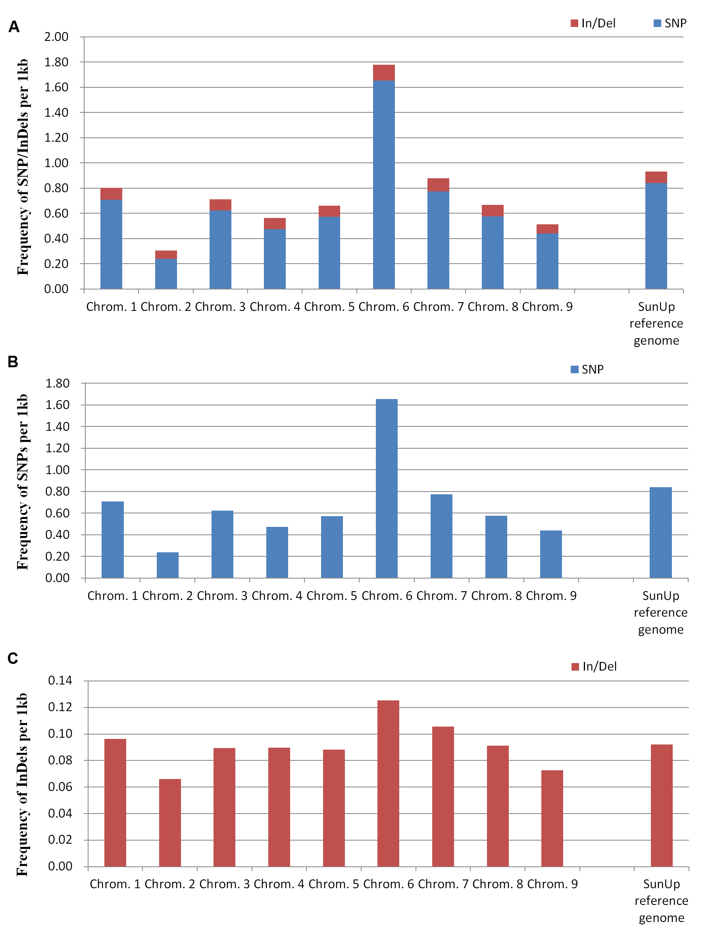
Additional file 4: Fig. S1 Chromosomal and genome-wide distribution of the frequency of A. SNP/InDels B. SNPs and C. InDels per 1kb in the Sunset genome compared to the SunUp reference genome
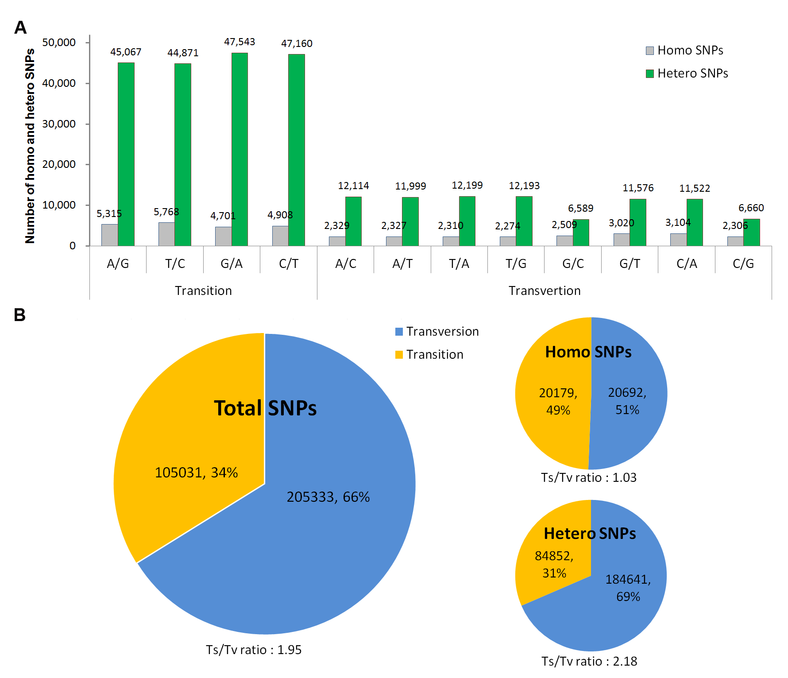
Additional file 5: Fig. S2 Transitions and transversions of homo and hetero SNPs identified in the Sunset genome compared to the SunUp reference genome. A. Frequency of different nucleotide substitution types in homo and hetero SNPs. B. Numbers and percentages of transitions (Ts) and transversions (Tv), and the Ts/Tv ratio in homo/hetero SNPs and total SNPs.

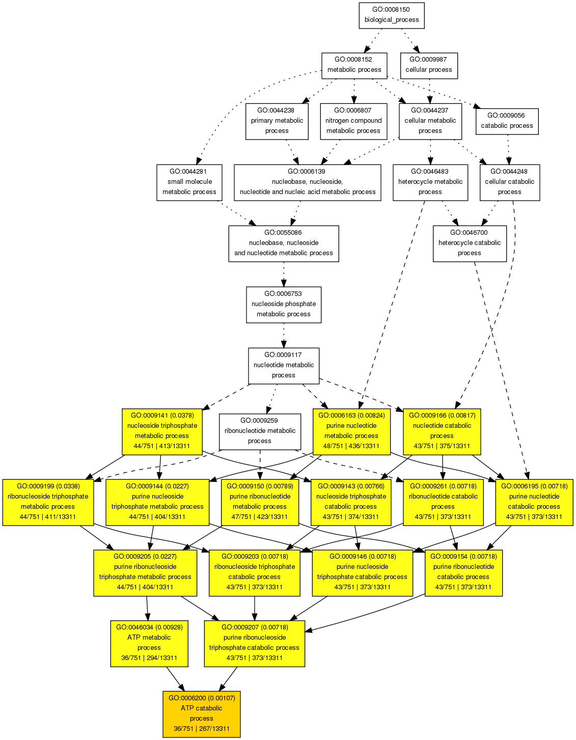
Additional file 6: Fig. S3 AgriGO results of putative high mutation genes based on SEA analysis. Significance level of enrichment is displayed using a color scale. White indicates no significant enrichment; color transitions from yellow to red indicate an increase in the strength of significance. Ratios at the bottom of each GO box represent the number of genes in the input list matching that GO term versus the number of total genes in the input list, total genes in the background genome set matching that GO term versus total genes in the background set. The adjusted p-value for each enriched GO term is indicated in parentheses at the top of each colored box.

